Question: Create a web page to print a paragraph with 4-5 sentences, each sentence shall have a different font.

<!DOCTYPE html>
<html lang="en">
<head>
<meta charset="UTF-8">
<meta name="viewport" content="width=device-width, initial-scale=1.0">
<title>Different Fonts Paragraph</title>
<style>
.sentence1 {
font-family: 'Arial', sans-serif;
}
.sentence2 {
font-family: 'Algerian', serif;
}
.sentence3 {
font-family: 'Bell MT', sans-serif;
}
.sentence4 {
font-family: 'Broadway', monospace;
}
.sentence5 {
font-family: 'Bahnschrift', serif;
}
</style>
</head>
<body>
<p>
<span class="sentence1">This is the first sentence of our paragraph, styled with Arial.</span>
<span class="sentence2">The second sentence follows, presented in Algerian.</span>
<span class="sentence3">Here is the third sentence, utilizing the Bell MT font.</span>
<span class="sentence4">And now, the fourth sentence, displayed in Broadway.</span>
<span class="sentence5">Finally, the fifth sentence concludes the paragraph, rendered in Bahnschrift.</span>
</p>

</body>
</html>

Question: Create a web page and show the output from 1 to 10 in separate lines, each number being in different colour.
<!DOCTYPE html>
<html lang="en">
<head>
<meta charset="UTF-8">
<meta name="viewport" content="width=device-width, initial-scale=1.0">
<title>Numbers in Different Colors</title>
<style>
.color-1 { color: red; }
.color-2 { color: blue; }
.color-3 { color: green; }
.color-4 { color: orange; }
.color-5 { color: purple; }
.color-6 { color: teal; }
.color-7 { color: brown; }
.color-8 { color: navy; }
.color-9 { color: olive; }
.color-10 { color: maroon; }
</style>
</head>
<body>
<p class="color-1">1</p>
<p class="color-2">2</p>
<p class="color-3">3</p>
<p class="color-4">4</p>
<p class="color-5">5</p>
<p class="color-6">6</p>
<p class="color-7">7</p>
<p class="color-8">8</p>
<p class="color-9">9</p>
<p class="color-10">10</p>
</body>
</html>
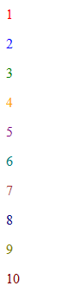

Question: Create a table in HTML using rowspan and colspan to organize the student records , displaying name , roll number, and marks.
<!DOCTYPE html>
<html lang="en">
<head>
<meta charset="UTF-8">
<meta name="viewport" content="width=device-width, initial-scale=1.0">
<title>Student Records</title>
<style>
table {
width: 80%;
border-collapse: collapse;
margin: 20px auto;
}
th, td {
border: 1px solid #ccc;
padding: 8px;
text-align: center;
}
th {
background-color: #f2f2f2;
}
</style>
</head>
<body>

<h1>Student Performance Report</h1>

<table>
<thead>
<tr>
<th rowspan="2">Roll Number</th>
<th colspan="2">Student Details</th>
<th colspan="3">Marks</th>
</tr>
<tr>
<th>First Name</th>
<th>Last Name</th>
<th>Math</th>
<th>Science</th>
<th>English</th>
</tr>
</thead>
<tbody>
<tr>
<td>101</td>
<td>Alice</td>
<td>Smith</td>
<td>85</td>
<td>92</td>
<td>78</td>
</tr>
<tr>
<td>102</td>
<td>Bob</td>
<td>Johnson</td>
<td>70</td>
<td>88</td>
<td>95</td>
</tr>
<tr>
<td>103</td>
<td>Charlie</td>
<td>Brown</td>
<td>90</td>
<td>75</td>
<td>82</td>
</tr>
<tr>
<td colspan="3">Total Marks (Average)</td>
<td>81.67</td> <!-- (85+70+90)/3 -->
<td>85</td> <!-- (92+88+75)/3 -->
<td>85</td> <!-- (78+95+82)/3 -->
</tr>
</tbody>
</table>

</body>
</html>

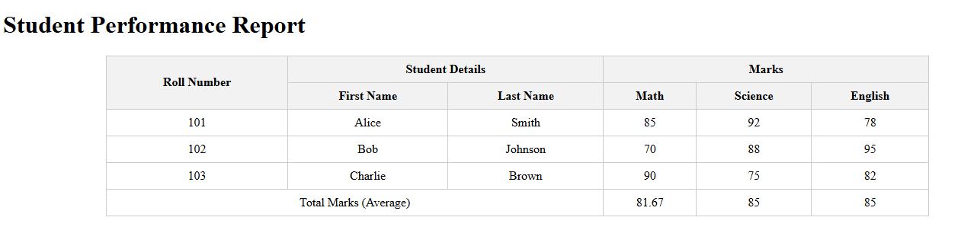

Question: Write HTML code to print your name using Heading tag, every letter shall be of different heading size.

<!doctype html>
<html lang="en">
<head>
<meta charset="utf-8" />
<meta name="viewport" content="width=device-width,initial-scale=1" />
<title>One-letter Headings</title>
<style>
body {
display: flex;
justify-content: center;
align-items: center;
min-height: 100vh;
margin: 0;
font-family: system-ui, -apple-system, "Segoe UI", Roboto, "Helvetica Neue", system-ui, -apple-system, BlinkMacSystemFont, 'Segoe UI', Roboto, Oxygen, Ubuntu, Cantarell, 'Open Sans', 'Helvetica Neue', sans-serif;
background: #f7f7fb;
}
.name {
display: flex;
gap: 6px;
align-items: baseline;
}
.letter-1 { font-size: 64px; margin:0; }
.letter-2 { font-size: 56px; margin:0; }
.letter-3 { font-size: 48px; margin:0; }
.letter-4 { font-size: 40px; margin:0; }
.letter-5 { font-size: 32px; margin:0; }
.letter-6 { font-size: 24px; margin:0; }
.letter-7 { font-size: 20px; margin:0; }
.letter-8 { font-size: 18px; margin:0; }
.letter-9 { font-size: 16px; margin:0; }
.letter-10{ font-size: 14px; margin:0; }
.letter-11{ font-size: 12px; margin:0; }
.name h1, .name h2, .name h3, .name h4, .name h5, .name h6 {
font-weight: 700;
line-height: 1;
color: #750912;
}
</style>
</head>
<body>
<div class="name" algerian="Outstanding">
<h1 class="letter-1">o</h1>
<h2 class="letter-2">u</h2>
<h3 class="letter-3">t</h3>
<h4 class="letter-4">s</h4>
<h5 class="letter-5">t</h5>
<h6 class="letter-6">a</h6>

<h1 class="letter-7">n</h1>
<h2 class="letter-8">d</h2>
<h3 class="letter-9">i</h3>
<h4 class="letter-10">n</h4>
<h5 class="letter-11">g</h5>
<h4 class="letter-11" role="heading" algerian="11">G</h4>
</div>
</body>
</html>


Question: Write HTML code to create a web page with a heading at the top-center and an image below it, centered on the page using basic HTML and CSS.

<!DOCTYPE html>
<html>
<head>
<title>Centered Heading and Image</title>
<style>
body {
text-align: center;
font-family: Arial, sans-serif;
margin-top: 40px;
}

img {
width: 300px;
height: auto;
}
</style>
</head>

<body>

<h1>Welcome to My Web Page</h1>

<img src="https://via.placeholder.com/300" alt="Sample Image">

</body>
</html>


Question: Write HTML code to design a simple form with controls like textbox, textarea, password, submit button, browse button,and a drop-down menu.

<!DOCTYPE html>
<html>
<head>
<title>Simple Form</title>
</head>
<body>

<h2>Sample Form</h2>

<form>
<label>Name:</label>
<input type="text" name="username"><br><br>
<label>Password:</label>
<input type="password" name="password"><br><br>
<label>Comments:</label><br>
<textarea name="comments" rows="4" cols="30"></textarea><br><br>
<label>Upload File:</label>
<input type="file" name="file"><br><br>
<label>Select Country:</label>
<select name="country">
<option value="india">India</option>
<option value="usa">USA</option>
<option value="uk">UK</option>
<option value="canada">Canada</option>
</select><br><br>
<input type="submit" value="Submit">

</form>

</body>
</html>

